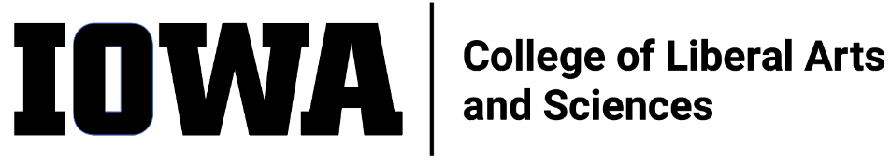
STAFF COUNCIL MONTHLY MEETING
DRAFT Agenda
Wednesday 12/15/21, 10:30 a.m.
Hybrid meeting via Zoom and in person at Schaeffer Commons (302SH)
Join Zoom Meeting
https://uiowa.zoom.us/j/91858901247

- Call to order
- Minutes approval (from 11/17/2021)
- New Business
  - Inviting new AVP Chris Cheatam (start date Jan. 17) and Strat Comm Director Ben Hill (Dec. 6) to upcoming meetings
  - Becca Tritten has resigned from SC – Announce / welcome new SC member
  - Discuss CLAS SC in-service / retreat: Emma will bring some ideas/options

- Committee and Ex-Officio updates (Committee reports at end of agenda)
  - Awards
  - Bylaws
  - Communications – Update on FB page launch and visioning event plans
  - DEI – Meeting on Friday December 17
  - Education
  - Executive – We will use the new OSC merch storefront (https://uiowa.authenticmerch.com/) to source prizes for drawing. Discuss whether current SC members are eligible to win?
  - Ex-Officio
  - UI Staff Council

- HR
- ASG
- Old Business
- Adjourn

Next meeting – Wednesday, 1/19/22, 10:30 a.m. Zoom/hybrid

Agenda item(s) for next meeting:

