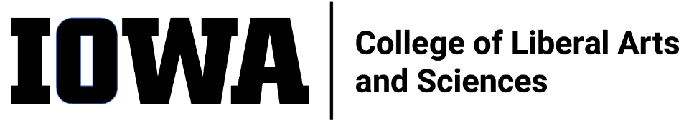
STAFF COUNCIL MONTHLY MEETING
Agenda
Wednesday 9/21/22, 10:30 a.m.
HYBRID
In-person: 302SH, or
Join Zoom Meeting
https://uiowa.zoom.us/j/98191553384
- Call to order by President
- Minutes approval (8/17/22)
- New Business
  - Dean’s office 9/7 meeting debrief (Mark)
  - Communications around elections process (Elections Committee)
  - CLAS Staff group Brown Bag Lunches (Tiffany via Sylvia)
  - CLAS Staff Council Executive team meeting notes
  - Visioning Event Recap
    - Need volunteers for the findings report: deadline Sept. 30th
- Old Business

- Committee updates

- Ex-Officio updates

- Adjourn

ITEMS FOR FUTURE AGENDAS:
- Discuss periodic, traveling coffee talk / Staff Council gatherings to build community, raise awareness about Staff Council, engage staff, recruit new Council members

