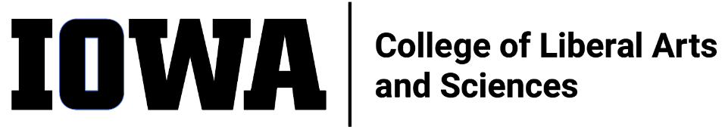
STAFF COUNCIL MONTHLY MEETING MINUTES
Wednesday 10/19/2022, 10:30 a.m.
Join Zoom Meeting
https://uiowa.zoom.us/j/6506866751

Call to Order 10:30 am

Present:

Absent:

September minutes approval: Deferred to November

- New Business
  - Dr. Liz Mendez Shannon – introduction and presentation
    - Started 6 weeks ago and in these weeks has been on listening tour to get a sense for how CLAS staff/faculty/students understand DEI and talking about vision for DEI in CLAS
    - Take aways – recruitment tends to be good, retention needs work; need structure for mentorship; focus on anti-racism; operate with/identify distinction; funding
    - Small group discussion among meeting attendees on their experience and definition of DEI
    - Philosophy/approach –
    - “Courageous Conversations” - stay engaged, experience discomfort, speak your truth, expect & accept non-closure
    - Leadership style – adaptive
    - Goals
      - Promote an Inclusive Environment
      - Build stronger infrastructure to support DEI efforts
    - Questions – how to operationalize? How to define effectiveness? Timeline?
    - Two year plan
      - Year 1 – review department DEI statements and implementation, assess diversity initiative, understand departmental mentoring
      - Year 2 – invest in structure and culture to support mentoring [ASIDE what is known now need structure, can’t be completely informal; doesn’t have to be within same unit], define equity, create toolkit
    - Next step – create workgroups to take up these goals, likely to be discussed/activated in next CLAS DEI monthly meeting
    - Future communication – utilize Mark F. as liaison between DEI committee and CLAS Staff Council, consider quarterly meetings with Dr. Mendez Shannon
  - Dean’s Office staff structure and vision by Becca Tritten
    - “Chief of Staff” position/function (Senior Director of Administration title) as of July 2022
    - Objectives – build systems for continuity/succession planning, build connections between 240 SH and 120 SH, elevate role of admin
    - Org chart (note admin services specialist 120 SH position filled by Maureen O’Neill):
- 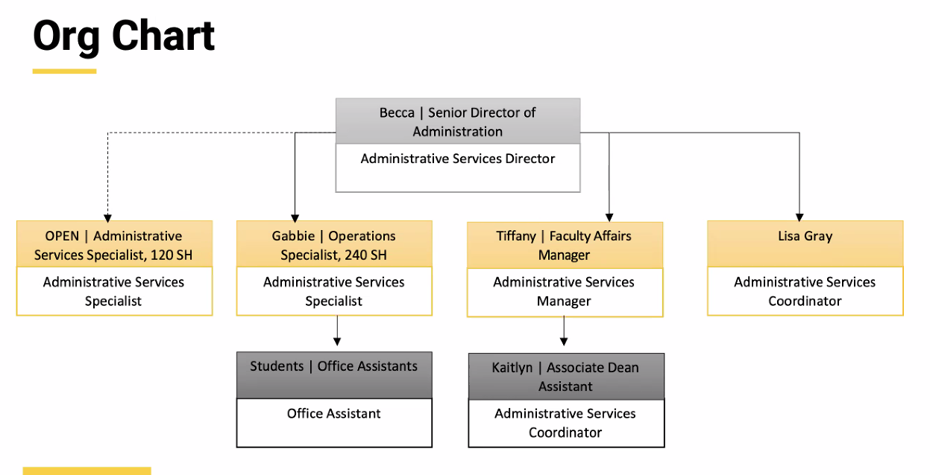
    - Description of CLAS committee structure (elected governance bodies, appointed governance bodies, leadership operations) and review senior leadership team
    - Discuss standing meetings between Dean Sanders and groups and chief of staff meetings (on rotating basis).
    - Chief of staff plans to meet regularly with finance, HR, marketing/communication, DEI committee, faculty, undergraduate programs, IT, grants, sustainability
  - Dean’s office departmental meeting 10/5 summary (Mark F.) –
    - Change coming to FLEX benefits – new vendor, debit card should simplify purchasing/reimbursement)
    - Review planned facilities changes – speech & hearing to have new facility on W side of river near Gerdin and field house (currently a parking lot), field house to come down, remodel Pentacrest with 1st priority given to MLH (pending funding), Halsey to come down and dance moves to old art museum, UI leadership to move to Gillmore, and old Art Building being repurposed
  - Proposal to work with Blair Wagner (Alli R.) – exec committee met with Blair Wagner, Organizational Change Manager, central HR. Opportunity to have training/coaching with CLAS Staff Council members over next 9-12 months with potential to develop “Lead where you are” initiative. Will present idea to Dean Sanders at next meeting with exec committee.

- Old Business
  - Visioning Event Report – emailed to Dean Sanders this week. Exec Committee meeting with Dean Sanders postponed from 10/13 to 10/20. After discussion with Dean Sanders intention is to circulate the report to all CLAS staff
  - Committee updates – reminder that committees should meet monthly, have selected a chairperson, and submit report of monthly activities prior to regular CLAS Staff Council monthly meeting (either by email to secretary or by uploading in Teams)
    - Communications – no chair selected yet, email has been sent to new staff, and newsletter is slightly delayed but may be out before end of October. Newsletter will use UI dispatch template so will look a bit different.
    - Awards – planning underway for next recognition event, scheduled for SU23, seeking donations from departments for prizes. Individual/unique items/experiences are preferred and appreciated. Development award nomination deadline is 11/11 and committee will review after that date.
    - Ex-officio reports
      - Updates from Rosie (Administrative Leadership Team Liaison)
From 10/04/2022 ALT Meeting:
        - Updates from Tom Koeppel (staying through June 2024) – budget goal is $154 mil; if there are “savings,” calls for strategic initiatives/departmental improvements will be put out & ADs will use dept. strategic plans to evaluate requests.
        - New CLAS internal-communication committee formed to evaluate DEO mailing, Business Brief, and CLAS newsletter
        - Faculty Affairs Update from Tiffany Schier – Shared update to point of contact in Dean’s Office for Faculty Resignations and Retirements; reminders on search process for adjuncts and visitors. Offer Letter Database coming (made by Tiffany); shared updates to offer letter process for signatures
        - Exec Meeting Update from Troy – next meeting for ALT Executive Board with Dean’s Office will be Oct. 18th.
        - Updates from Becca (Senior Director of Administration)
          - The next CLAS Faculty Assembly meeting is Wednesday, October 19. The main agenda item is a budget update, presented by Tom Koeppel and Sara Sanders.
        - Ben Hill, Senior Director of Strategic Communications and Marketing provided a quarterly report to the recent DEO Meeting and the CLAS Executive Committee.
      - Updates from Julie (Senior Director of Human Resources)
        - Working at Iowa Survey is now live through 10/27. Please encourage faculty and staff to participate. Currently only 25% complete, which is behind pace of other units within UI.
        - The search for a new HR Director (vacated by Diane Fountain) is underway. The position posting closed on 10/17.
        - CLAS HR leadership is currently reviewing the key performance indicators from the first quarter of the fiscal year for talent acquisition.
        - New Criminal Background Check guidelines – local decision making for minor offenses, anything above that requires consultation with OGC and University HR/Office of Provost.
      - Updates from Karen (UI Staff Council, Org Rep)
        - From 10/12/2022 UI Staff Council Meeting:
          - Well-Being Collaborative, Nutrition– Steph Beecher, Student Care & Assistance/Office of the Dean of Students and Megan Hammes, Senior Director UI Wellness
          - Health and Well-being Fair Update - Megan Hammes, Senior Director UI Wellness and Wendy Askling/Jordan Immerfall, Co-chairs Education Committee – Wednesday, November 2, 7:30 am – 2 pm in UI Field House
          - Enrollment Management Update – Brent Gage, Associate Vice-President for Enrollment Management – Presentation contained many statistics about the Fall 2022. I will share the slide deck once I receive it.
Sandy M. moves to adjourn
Second by Sylvia G.

