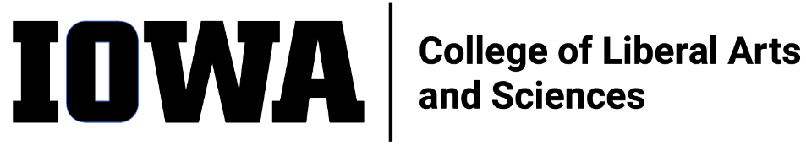
STAFF COUNCIL MONTHLY MEETING
Agenda
Wednesday 12/21/22, 10:30 a.m.
HYBRID
In-person: 240SH, or
Join Zoom Meeting
https://uiowa.zoom.us/j/98191553384
- Call to order by President
- Minutes approval (11/16/22)
- New Business
  - New UI SC ex officio (replacing Karen Noggle)
    - Brad Carson
  - Spring Meetings Roundtable
    - Action items from Visioning Event report
      - Work with Collegiate Leaders
  - Brown Bag Event Coordination (Adam, Mallory)
    - Spring date?
    - Additional committee members?
  - Communications Team update
    - How CLAS SC will interface with CLAS MarCom
  - EC Meeting with Dean Dec 8
    - Topic of discussion
  - Dean’s office meeting debriefs (Mark/Rebecca)
- Old Business
  - Visioning Event Report general response from Dean’s office
    - DEI Workgroups being created (15-18 people)
      - Should CLAS SC formalize representation on DEI committee?
- Committee updates

- Ex-Officio updates

- Adjourn

ITEMS FOR FUTURE AGENDAS:
Discuss periodic, traveling coffee talk / Staff Council gatherings to build community, raise awareness about Staff Council, engage staff, recruit new Council members

