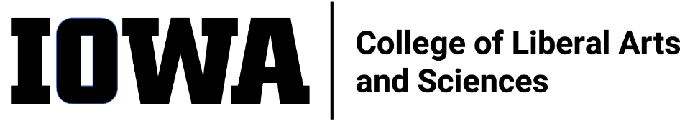
STAFF COUNCIL mONTHLY MEETING
MINUTES
Wednesday 1/18/23, 10:30 am
HYBRID
In-person 240 SH and
via Zoom Meeting
https://uiowa.zoom.us/j/98191553384
Attendance in Person: Mark F., Emma K. (ex-officio, past-pres), Alli R., Jen K., Adam S., Sylvia G., George C, Mallory H., Rebecca T. (ex-officio – dean’s rep), Julie R. (ex-officio – HR), Bradley Carson; Attendance via Zoom: Rebekah P., Shonda M., Leyre C., Sandy M., Rosie S. (ex-officio – ALT)

Not present: None

Guests: Liz Mendez, Maureen Walterhouse, Corey Campbell, Joe Cilek, Julie Jones, Kate, KNI, Maggie Atkinson, Kyle McEvilly

Call to Order by Mark F. at 10:36a
Minutes (12/21/22) accepted by Sandy M., seconded by Rebekah P.
Presentation by Julie R. (HR Sr. Director): Flexible Work Arrangements
- Slide deck on Teams in the January 2023 meeting materials folder
New Business
- Spring meetings roundtable scheduling update
  - CLAS SC meeting invites to CLAS leadership to discuss Visioning Event Report action items
    - Feb 15 – Julie R. – Performance Management/Reviews
    - March 8 – Communications – Ben Hill
    - April 19 – Liz Mendez-Shannon – DEI
    - May 17 – Chris Cheatum and Roland Racevski – Strategic Planning
    - TBD – Tom Koeppel – Finances & Raises
      - President Wilson looking to see equity across campus
- Visioning Event Report sent to CLAS Staff with invite to Spring Roundtable Meetings
- Considerations discussed for SC Retreat and other events
  - UI SC funding application simple and short
  - Focus on growth, professional development and community building
- CLAS SC to send Thank You to UI SC for funding the Visioning Event
  - Using new card designed by CLAS SC
- CLAS SC EC Meeting w/ Dean Sanders postponed to later today
Old Business
- Brown Bag Event Coordination (Adam, Mallory)
  - Push to next month agenda
  - Need functioning committee
  - Seeking funding options (Wellness grant, etc.)
Committee Updates (see reports on Teams)
- UI Staff Council (Brad)
  - Notes to be shared on Teams
- Communications (Adam)
  - Nomination notes and Elections primer with staff spotlights (Jen K. and Shonda M.) on CLAS SC website
- Dean’s Office Debrief (Mark)
  - Overview given; Notes to be shared on Teams
  - Topics: SC President duties and expectations; Admissions, DEI, Staff Recognition, Cool IT involvement, Finances, Dean Sanders expanding fundraising travels and expanded roles (not divulged)
- Ex Officio Updates
  - HR (Julie)
    - CLAS to implement Community Onboarding for Staff
      - ½ day event
      - Introduce new staff to all the cool spaces, groups and activities within CLAS
      - Opportunity to meet people outside of the areas being hired into
      - Feedback surveys immediately following and 6 months out
      - Expect cohorts of 15-20
        - Hiring Snapshot: hired 60 new staff (15% of total)
      - Piloting in March
  - DEI Toolkit Workgroup meeting later today (Emma)
Motion to adjourn at 11:50a by Mark F., seconded by Adam S.

ITEMS FOR FUTURE AGENDAS: --

