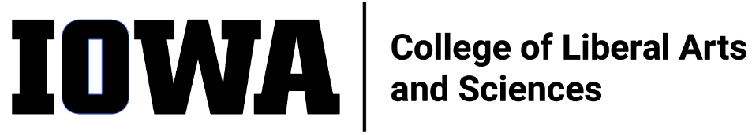
STAFF COUNCIL mONTHLY MEETING
MINUTES
Wednesday 11/16/22, 10:30 am
Join Zoom Meeting
https://uiowa.zoom.us/j/98191553384
In attendance: Rebekah P., Alli R., Emma K. (ex-officio, past-pres), Shonda M., Jen K., Leyre C., Rosie S. (ex-officio – ALT [formerly ASG]), Sandy M., Sylvia G., George C, Mallory H., Rebecca T. (ex-officio – dean’s rep),), Adam S.

Not present: Karen N. (ex-officio – UI Staff Council), Mark F., Julie R. (ex-officio – HR

Guests: Ben Hill, Katie Linder

Call to Order by Alli at 10:32a
Strategic Comm presentation:
- Update incomplete but focus on SC relevant info
- Team tripled in size – still considered small
- Focus on positioning the college – lacks identity
  - Summer work with leadership team what is critical to the audiences (faculty, students, staff)
  - Increase/improve internal communications – Katie’s position
    - Newsletter
    - Recommendations from the Visioning Event
    - Committee formed – ICRC
      - Survey sent – due Dec 2
        - Want feedback from SC to increase circulation
        - ALT to recirculate
    - Strategic Comm to coordinate with SC to align communications with Staff
    - Info not duplicated; limited feeding of info to produce content
      - Email content to clas-marcom@uiowa.edu
    - Katie to attend SC Comm Comm meetings
Minutes (9/21/22) accepted by Sandy, seconded by Rebekah
Minutes (10/19/22) accepted by Emma, seconded by Shonda
Dean’s office meeting debrief (Rebecca)
- Mark’s presentation was well received
Brown Bag Event Coordination (Adam, Mallory)
- Delayed due to newsletter prep
- Planning event for Spring
Karen Noggle replacement
- There is some confusion
- UI SC bylaws: she can continue in her role for the remainder of the operational year with org approval
  - UI SC deferring to org (CLAS SC)
  - CLAS SC bylaws refers to elected officials which would create a vacancy
    - Rebecca: Karen is willing to continue; we should consider defaulting to UI SC bylaws
    - Mark: prefers org rep from org
      - Asked Lisa to proceed as vacancy reaching out to election runner-up
    - Adam: setting precedent
    - Multiple members:
SLT response to Visioning Event Report
- EC meeting w/Dean postponed
- Rebecca: report discussed at SLT meeting
  - Work started in summer regarding review process
  - DEI Work groups being created (15-18 people)
    - Should SC formalize representation on DEI committee?
Committee Updates (see reports on Teams)
- Elections Committee (Alli)
  - Met with SLT to consider what can be done to adjust MOP to handle elections internally
    - Changes will not be ready for 2023 elections
    - Interpretations are conflicting
      - Full revision of CLAS MOP coming in 2024
        - Hopeful approach to CLAS SC in CLAS MOP: CLAS SC viewed as governing body and default to bylaws (bylaws need to be overhauled as well)
  - Committee welcomes feedback
  - Hope to reach 50% participation in elections
- Awards Committee (Sylvia)
  - Reviewing professional development awards today
- Communications Committee (Mallory)
  - Mallory voluntold she is the committee chair
  - SC newsletter is out
  - Taking feedback for website/newsletter content
    - Include SComm email address
    - Broaden SC feedback tool to include content suggestions
  - Facebook page updates
    - Who has access: Mark, Emma, Jen
    - Not being updated
  - Promotion strategy for elections – timing and targets
    - Nomination period begins in February
    - Coordinated with Dean’s office
  - Add Instagram
- DEI Committee (Jen)
  - Engage more staff in DEI.
- Education Committee (Sandy)
  - Did not meet
  - Late on newsletter submission – good for next newsletter
- Ex Officio
  - ALT (Rosie) – none, next meeting Nov
  - Dean’s Office (Rebecca) – HoCo parade participation went well, Faculty assembly update
  - HR –
Motion to adjourn at 11:47a by _______, seconded by Adam.

ITEMS FOR FUTURE AGENDAS: --

