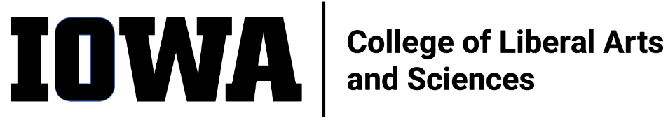
STAFF COUNCIL mONTHLY MEETING
MINUTES
Wednesday 12/21/22, 10:30 am
HYBRID
In-person 240 SH and
via Zoom Meeting
https://uiowa.zoom.us/j/98191553384
In attendance: Mark F., Rebekah P., Shonda M., Jen K., Leyre C., Rosie S. (ex-officio – ALT), Sylvia G., George C, Mallory H., Rebecca T. (ex-officio – dean’s rep), Adam S., Julie R. (ex-officio – HR), Bradley Carson

Not present: Alli R., Emma K. (ex-officio, past-pres), Sandy M.

Guests: Katie Linder

Call to Order by Mark at 10:34a
Minutes (11/16/22) accepted by George, seconded by Sylvia
New Business
- Introductions
  - Brad Carson replacing Karen Noggle as ex-officio for UI Staff Council
  - Round table introductions of those present
- Spring meetings roundtable scheduling update
  - CLAS SC meeting invites to CLAS leadership to discuss Visioning Event Report action items
    - DEI – Liz Mendez
    - Communications – Ben Hill
- CLAS SC to send Thank You to UI SC for funding the Visioning Event
- Commencement Marshalls
  - Recommended by SC participants
  - Volunteers received lunch
  - Ceremony was student focused
    - Reduced number of and length of speeches
  - Will get requests for spring volunteers out early
Old Business
- Brown Bag Event Coordination (Adam, Mallory)
  - Push to next month agenda
  - Need functioning committee
- Visioning Event Report – see items above
Committee Updates (see reports on Teams)
- Communication Committee
  - Will be combining CLAS SC Newsletter with MarComm Faculty & Staff Newsletter
    - Decision supports staff desire to see increased presence in MarcComm Newsletter
    - Decision also reduces work for CLAS SC Comm Committee
    - Will still collect staff feedback via CLAS SC website
- DEI Committee
  - Members attending CLAS DEI Committee meetings – next meeting, Jan 30
    - Charges to Workgroups
      - Mentoring
      - Equity Audit (hiring, evals, promotions, student evals, faculty service)
      - DEI Toolkit (instruction, faculty, faculty, staff, students)
        - Next meeting Jan 18
  - Look at MOPS to formalize connection w/ CLAS DEI Committee
- Elections Committee
  - After discussions with Becca, decided to wait for MOPS to be corrected before making changes
  - Work w/ SC Comm Comm and MarComm to improve announcements and language as well as improve ballot structure
    - Highlight in Jan MarComm newsletter
- Exec Committee
  - Meeting with Dean Sanders rescheduled
  - To discuss improved communication, DEI and strategic planning initiatives
- Dean’s Office Meeting Debrief
  - HR Staffing Updates – lots of changes but with familiar faces
    - Current staff elevated, searches for generalists and coordinators
  - Mental Health Training and initiatives
    - Connect staff with resources
      - Kognito – Distress Intervention and Suicide Prevention Program
        - Self-guided course offered through Self Service
        - Needed due to uptick in suicide cases
        - Goal is to expect all CLAS SC members to take the course
          - Lead by example
    - Will introduce at Jan 30 DEO/ALT meeting
    - To be highlighted for the next several months
  - Communication Building examples
    - Finances
      - On track with budget improvement, $1.7M saved
      - Advocating for additional $10M to be added to CLAS budget
      - It’s a team effort – departments are helping to determine budget allocations
    - Deans & CLAS SC working in collaboration to improve communication
      - Want to hear from the deans directly
    - Visioning Event Report & feedback

Motion to adjourn at 11:50a by Jen K., seconded by Sylvia G.

ITEMS FOR FUTURE AGENDAS: --

